
AGS-TECH Inc
Phone: +1-505-550-6501 and +1-505-565-5102
Fax: +1-505-814-5778
Email: sales@agstech.net
Web: http://www.agstech.net
MH600 Portable Hardness Tester
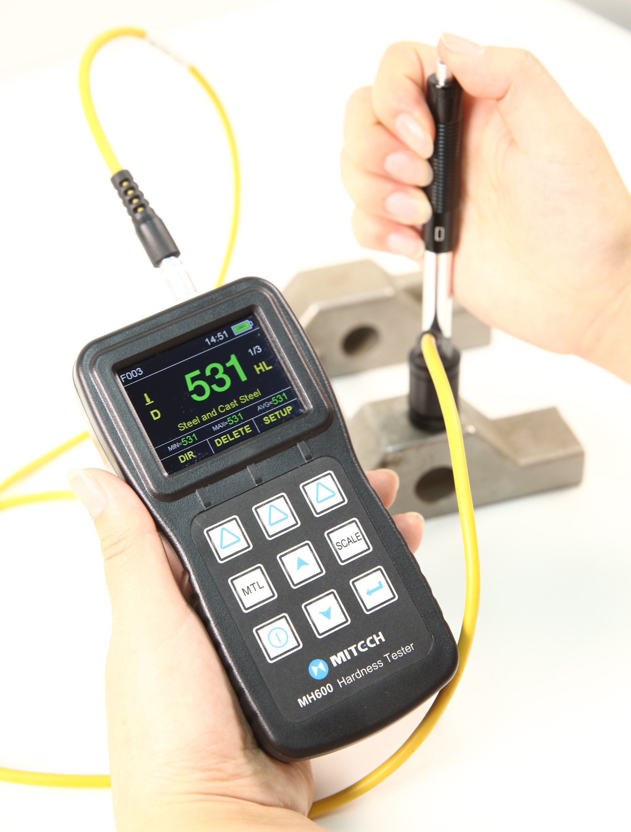

Advantages
- Wide measuring range. Based on the principle of Leeb hardness testing theory, it can measure the hardness and strength for various metallic materials.
- Compatible with seven types of impact devices. It can identify the impact device type automatically without needing re-calibration when changing the impact device.
- Automatically checking the impact device statue (connect, disconnect, breakdown and so on).
- Automatically identify the impact direction (except for G impact device). It can support 360°all-around measurements.
- Full digital color TFT 320*240 dot matrix LCD with rich and intuitive information, adjustable brightness to easily use under the dimly light and strong sunlight.
- Basic (single-point) calibration and original multi-point calibration function. It can do multi-point calibration to the convert curve to reduce measurement error.
- Test result can be transferred among HL, HB, HRB, HRC, HRA, HV, HS.
- Integrated the leeb hardness conversion function, it can realize convert among HLD and HLC, HLG, HLDL, HLD + 15 which is conveniently for instrument calibration and test result conversion.
- Preset the up and down limitation for the hardness value. Automatically alarm function out of the limitation is very easily for user’s demand of batch testing.
- Freely switch Chinese and English. Menu operation used very easy.
- Save 500 groups hardness testing values (relative to impact times 32～1). Each group data included single testing value, average value, testing date and time, impact direction, count, material, hardness scale and so on.
- With two common AA sizes batteries, it can work continuously for not less than 100 hours. It has power saving function like automatic standby screen, automatic sleeps and automatic shutdown.
- With USB1.1 port, it can connect with PC very easily and quickly.
- Equipped with PC-side data proceeding software, it has rich features like transfer testing result, storage management, statistical analysis, generate measurement reports and so on.
- Specially designed for harsh environments, it is very sturdy and durable. With its unique seal design, it can withstand moisture, sand, oil and other contaminants from the ocean to the desert and various harsh environments.
- Outline Size: 150mm×76mm×38mm

Main Application
- Die cavity of molds
- Bearings and other parts
- Failure analysis of pressure vessel, steam generator and other equipment
- Heavy work piece
- The installed machinery and permanently assembled parts
- Testing surface of a small hollow space
- Material identification in the warehouse of metallic materials
- Rapid testing in large range and multi-measuring areas for large-scale work piece

Technical Specifications
- Measuring range：HLD（170～960）HLD
- Measuring direction：360°. It can be identify the testing direction automatically.
- Measuring Materials: Steel and cast steel, cold work tool steel, stainless steel, grey cast iron, nodular cast iron, cast aluminum alloys, brass (copper-zinc alloys), bronze (copper-aluminum/tin alloys), pure copper, wrought copper.
- Hardness Scale：HL、HB、HRB、HRC、HRA、HV、HS
- Display：16 bits full digital color TFT 320x240 dot matrix LCD
- Integrated the transformation conversion table among HLD and HLC, HLG, HLDL, HLD + 15
- Data memory： 500 groups max.（relative to impact times 32～1）
- Working voltage：3V（2 AA size alkaline battery）
- Continuous working period：about 100 hours（With the default brightness）
- Communication interface：USB1.1

Configuration
 | No. | Item | Qty | Remarks
Standard Configuration | 1 | Main Unit | 1
Standard Configuration | 2 | D type impact device | 1
Standard Configuration | 3 | Standard test block | 1
Standard Configuration | 4 | Cleaning brush (I) | 1
Standard Configuration | 5 | Small support ring | 1
Standard Configuration | 6 | AA Size Battery | 2
Standard Configuration | 7 | Documents with Instruments | 1
Standard Configuration | 8 | Instrument Case | 1
Standard Configuration | 9 | Datapro Software | 1 | Used on PC.
Standard Configuration | 10 | USB Communication Cable | 1 | Mini USB-B to USB-A
Optional Configuration | 11 | Cleaning brush (II) | 1 | For use with G type impact device
Optional Configuration | 12 | Other type of impact devices and support rings |  | Refer to Table 3 and Table 4 in the appendix.

